Randall C. Crawford
Student ID: 901012194
Email: r.crawford2194@student.nu.edu
Course: ANA 615 Data Mining Techniques

Problem 2.2 (pg. 56)
Describe the difference in roles assumed by the validation partition and the test partition.
Answer: The validation partition is used to assess the performance of each supervised learning model so that we can compare models and pick the best one. In some algorithms (e.g., classification and regression trees, k-nearest neighbors) the validation partition may be used in automated fashion to tune and improve the model. This means that the validation data is actually used to help build the model.
The test data partition is used for assessing the performance of the final chosen model on new data. The test data are not used to compare models, or to further tweak the model or improve its fit. (If the test data were used for these purposes, they would play a role in building or selecting the best model, and would no longer provide an unbiased assessment of the chosen model's performance with completely new data.)

Problem 2.3 (pg. 56)
Consider the sample from a database of credit applicants in Table 2.16. Comment on the likelihood that it was sampled randomly, and whether it is likely to be a useful sample.

Answer: This sample is not selected randomly as we can see from “observation #”, that there is pattern in the observations chosen for the sample. In particular, every 8th observation from the database was selected for the sample. When we select data with such a pre-decided methodology it might introduce a bias in the selected data set. This is true when the order of the observations in the dataset has some meaning (e.g., chronological order).

Problem 2.4 (pg. 56)
Consider the sample from a bank database shown in Table 2.17; it was selected randomly from a larger database to be the training set. Personal Loan indicates whether a solicitation for a personal loan was accepted and is the response variable. A campaign is planned for a similar solicitation in the future and the bank is looking for a model that will identify likely responders. Examine the data carefully and indicate what your next step will be.

Answer: Since there are only 18 records and 9 predictor variables in the sample, the next step before building a model is to take a larger sample. 18 records are too few to support a model that considers 9 predictors. How big of a sample? The availability of data, the cost and effort involved in data handling, and software capabilities are the main constraining factors. Also, it is useful to check the number of available responses, and the response ratio, in the larger database. If the response ratio is very low, it would be worthwhile to oversample the cases where response is positive (or, in other words, under sample the non-response cases). Two other issues:
Zip code should probably be aggregated at a higher level than 5 digits, which would likely produce an unmanageable number of predictor variables. For example, it could be aggregated at the level of the first 3 digits.
It also seems that the key information in “Mortgage” is whether the person has a mortgage, and not so much the level of the mortgage, so some consideration could be given to converting this to a binary variable.

Problem 2.5 (pg. 57)
Using the concept of overfitting, explain why when a model is fit to training data, zero error with those data is not necessarily good.
Answer: Overfitting occurs when the model captures not only the generalizable pattern in the data, but also the error. When we split the data into training and validation sets, we assume that the same pattern (if there is a pattern) exists in both, and that they differ only in the error that they contain. An absurd and false model may fit perfectly (on training data set) if the model has enough complexity. Therefore, we may get zero error for such a model using the training dataset. Such a model, however, is not likely to give useful results on the validation data set.

Problem 2.6 (pg. 57)
In fitting a model to classify prospects as purchasers or nonpurchasers, a certain company drew the training data from internal data that includes demographic and purchase information. Future data to be classified will be lists purchased from other sources, with demographic (but not purchase) data included. It was found that “refund issued” was a useful predictor in the training data. Why is this not an appropriate variable to include in the model?
Answer: The variable “refund issued” is unknown prior to the actual purchase, and therefore is not useful in a predictive model of future purchase behavior. In fact, “refund issued” can only be present for actual purchases but never for non-purchases. This explains why it was found to be closely related to purchase/non-purchase.

Problem 2.7 (pg. 57)
A dataset has 1000 records and 50 variables with 5% of the values missing, spread randomly throughout the records and variables. An analyst decides to remove records with missing values. About how many records would you expect to be removed?
Answer: For a record to have all values present, it must avoid having a missing value (P = 0.95) for each of 50 records. The chance that a given record will escape having a missing value for two variables is 0.95 * 0.95 = 0.903. The chance that a given record would escape having a missing value for all 50 records is (0.95)^50 = 0.076945. This implies that 1-0.076944 = 0.9231 (92.31%) of all records will have at least one missing value and will be deleted.

Imported Libraries:
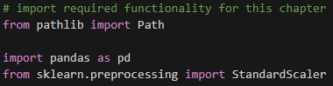

Problem 2.11
The dataset *ToyotaCorolla.csv* contains data on used cars on sale during the late summer of 2004 in the Netherlands. It has 1436 records containing details on 38 attributes, including *Price, Age, Kilometers, HP,* and other specifications.
We plan to analyze the data using various data mining techniques described in future chapters. Prepare the data for use as follows:
2.11.a. The dataset has two categorical attributes, Fuel Type and Color. Describe how you would convert these to binary variables. Confirm this using __pandas__ methods to transform categorical data into dummies. What would you do with the variable _Model_?
Answer: The categorical fuel_type variable has three categories: petrol, diesel and CNG. To convert these variables into dummy variables, we use only two variables (here we use Petrol and Diesel, but a different pair can also be chosen). The binary variable Petrol gets the value 1 if Fuel Type=Petrol and otherwise it gets the value 0. The binary variable Diesel gets the value 1 if Fuel Type=Diesel and otherwise it gets the value 0. CNG is the "reference category." If Fuel type is CNG, both binary variables take the value 0.
Similarly, the variable _Color_ is converted to dummy variables. It resulted in 10 dummy variables with "Color_Beige" as the reference category.
Making dummies of all the categories in _Model_ would make for a lot of predictor variables. Some preliminary exploration should be done first, to see if there are a small number of models that account for most cases. The analysis could be confined initially to those to see how important Model is as a predictor.

Code for 2.11.a:
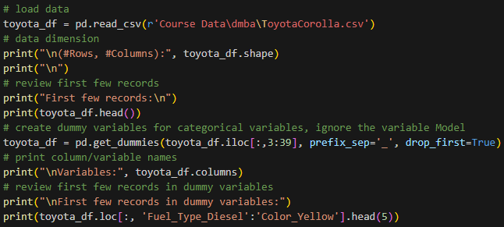

Output for 2.11.a:
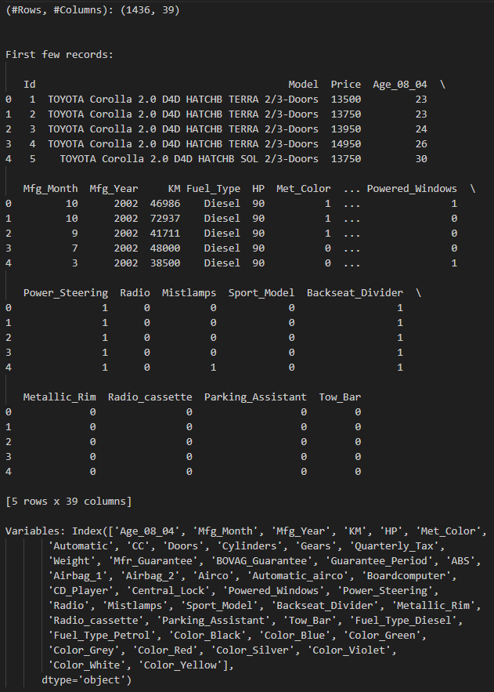
Output for 2.11.a (cont.):
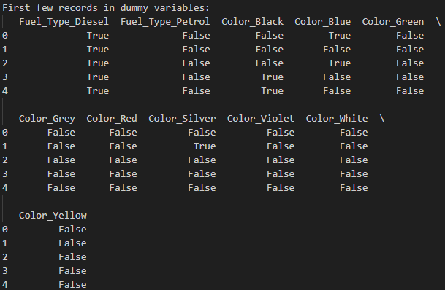

2.11.b. Prepare the dataset (as factored into dummies) for data mining techniques of supervised learning by creating partitions in Python. Select all the variables and use default values for the random seed and partitioning percentages for training (50%), validation (30%), and test (20%) sets. Describe the roles that these partitions will play in modeling.
Answer:
Code for 2.11.b:
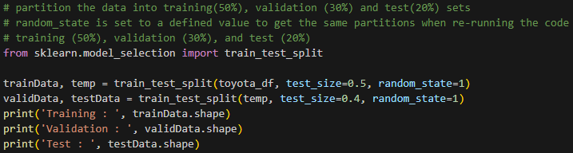

Output for 2.11.b:
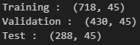

The training dataset is used to train or build models. For example, in a linear regression, the training dataset is used to fit the linear regression model, i.e. to compute the regression coefficients. This is usually the largest partition.
Once a model is built on training data, we assess the accuracy of the model on unseen data. For this, the model should be used on a dataset that was not used in the training process. In the validation data we know the actual value of the response variable, and can therefore examine the difference between the actual value and the predicted value to determine the error in prediction.
Based on this performance, sometimes the validation dataset is used to tweak the model, or to choose between multiple fitted models.
The validation dataset is often used to select a model with minimum error. Testing that model on completely unseen data gives a realistic estimate of the performance of the model. When a model is finally chosen, its accuracy with the validation dataset is still an optimistic estimate of how it would perform with unseen data. This is because (1) the final model has come out as the winner among the competing models based on the fact that its accuracy with the validation dataset is highest, and/or (2) the validation set was used to help build one or more models. Thus, you need to set aside yet another portion of data, which is used neither in training nor in validation, which is called the test dataset. The accuracy of the model on the test data gives a realistic estimate of the performance of the model on completely unseen data.
*It has been pointed out that there is a value in the cc variable - 16,000 - that is probably a data input error. The solutions have been prepared without correcting this error, but a solution that includes correcting this error to 1600 would also be fine. (The data could also be used as a small illustration or exercise of data prep and cleaning.)

# **2.4 Preliminary Steps - Predicting Home Values In The West Roxbury Neighborhood**
# *Loading And Looking At The Data In Python - TABLE 2.3*
# Import required packages.
import pandas as pd
# Load required data.
housing_df = pd.read_csv(r'Course Data\dmba\WestRoxbury.csv')
# Find the dimensions of the data frame.
housing_df.shape
(5802, 14)
# Show the first five rows of the data frame.
housing_df.head()
TOTAL VALUE TAX LOT SQFT YR BUILT GROSS AREA LIVING AREA FLOORS
0 344.2 4330 9965 1880 2436 1352 2.0
1 412.6 5190 6590 1945 3108 1976 2.0
2 330.1 4152 7500 1890 2294 1371 2.0
3 498.6 6272 13773 1957 5032 2608 1.0
4 331.5 4170 5000 1910 2370 1438 2.0
ROOMS BEDROOMS FULL BATH HALF BATH KITCHEN FIREPLACE REMODEL
0 6 3 1 1 1 0 NaN
1 10 4 2 1 1 0 Recent
2 8 4 1 1 1 0 NaN
3 9 5 1 1 1 1 NaN
4 7 3 2 0 1 0 NaN
# Rename columns: replace spaces with '_' to allow dot notation.
#housing_df = housing_df.rename(columns={'TOTAL VALUE ': 'TOTAL_VALUE'})
housing_df.columns = [s.strip().replace(' ', '_') for s in housing_df.columns] # all columns
# Show the first four rows of the data frame to verify previous change.
housing_df.loc[0:3] # loc[a:b] gives rows a to b, inclusive
#housing_df.iloc[0:4] # iloc[a:b] gives rows a to b-1
TOTAL_VALUE TAX LOT_SQFT YR_BUILT GROSS_AREA LIVING_AREA FLOORS
0 344.2 4330 9965 1880 2436 1352 2.0
1 412.6 5190 6590 1945 3108 1976 2.0
2 330.1 4152 7500 1890 2294 1371 2.0
3 498.6 6272 13773 1957 5032 2608 1.0

ROOMS BEDROOMS FULL_BATH HALF_BATH KITCHEN FIREPLACE REMODEL
0 6 3 1 1 1 0 NaN
1 10 4 2 1 1 0 Recent
2 8 4 1 1 1 0 NaN
3 9 5 1 1 1 1 NaN
# Show the first 10 values in the column TOTAL_VALUE.
#housing_df['TOTAL_VALUE'].iloc[0:10]
#housing_df.iloc[0:10]['TOTAL_VALUE']
housing_df.iloc[0:10].TOTAL_VALUE # use dot notation if the column name has no spaces
0 344.2
1 412.6
2 330.1
3 498.6
4 331.5
5 337.4
6 359.4
7 320.4
8 333.5
9 409.4
Name: TOTAL_VALUE, dtype: float64
# Show the fifth row of the first 10 columns in the data frame.
#housing_df.iloc[4][0:10]
#housing_df.iloc[4, 0:10]
housing_df.iloc[4:5, 0:10] # use a slice to return a data frame
TOTAL_VALUE TAX LOT_SQFT YR_BUILT GROSS_AREA LIVING_AREA FLOORS
4 331.5 4170 5000 1910 2370 1438 2.0
ROOMS BEDROOMS FULL_BATH
4 7 3 2
# Use pd.concat to combine non-consecutive columns into a new data frame.
# The axis argument specifies the dimension along which the concatenation happens, 0=rows, 1=columns.
pd.concat([housing_df.iloc[4:6,0:2], housing_df.iloc[4:6,4:6]], axis=1)
TOTAL_VALUE TAX GROSS_AREA LIVING_AREA
4 331.5 4170 2370 1438
5 337.4 4244 2124 1060

# To specify a full column, use:
#housing_df.iloc[:,0:1]
housing_df.TOTAL_VALUE
#housing_df['TOTAL_VALUE'][0:10] # show the first 10 rows of the first column
0 344.2
1 412.6
2 330.1
3 498.6
4 331.5
...
5797 404.8
5798 407.9
5799 406.5
5800 308.7
5801 447.6
Name: TOTAL_VALUE, Length: 5802, dtype: float64
# Descriptive statistics:
print('Number of rows ', len(housing_df['TOTAL_VALUE'])) # show length of first column
print('Mean of TOTAL_VALUE ', housing_df['TOTAL_VALUE'].mean()) # show mean of column
housing_df.describe() # show summary statistics for each column
Number of rows 5802
Mean of TOTAL_VALUE 392.6857149258877
TOTAL_VALUE TAX LOT_SQFT YR_BUILT GROSS_AREA
count 5802.000000 5802.000000 5802.000000 5802.000000 5802.000000
mean 392.685715 4939.485867 6278.083764 1936.744916 2924.842123
std 99.177414 1247.649118 2669.707974 35.989910 883.984726
min 105.000000 1320.000000 997.000000 0.000000 821.000000
25% 325.125000 4089.500000 4772.000000 1920.000000 2347.000000
50% 375.900000 4728.000000 5683.000000 1935.000000 2700.000000
75% 438.775000 5519.500000 7022.250000 1955.000000 3239.000000
max 1217.800000 15319.000000 46411.000000 2011.000000 8154.000000
LIVING_AREA FLOORS ROOMS BEDROOMS FULL_BATH
count 5802.000000 5802.000000 5802.000000 5802.000000 5802.000000
mean 1657.065322 1.683730 6.994829 3.230093 1.296794
std 540.456726 0.444884 1.437657 0.846607 0.522040
min 504.000000 1.000000 3.000000 1.000000 1.000000
25% 1308.000000 1.000000 6.000000 3.000000 1.000000
50% 1548.500000 2.000000 7.000000 3.000000 1.000000
75% 1873.750000 2.000000 8.000000 4.000000 2.000000
max 5289.000000 3.000000 14.000000 9.000000 5.000000
HALF_BATH KITCHEN FIREPLACE
count 5802.000000 5802.00000 5802.000000
mean 0.613926 1.01534 0.739917
std 0.533839 0.12291 0.565108
min 0.000000 1.00000 0.000000
25% 0.000000 1.00000 0.000000
50% 1.000000 1.00000 1.000000
75% 1.000000 1.00000 1.000000
max 3.000000 2.00000 4.000000
# Import additional required packages.
import numpy as np
from sklearn.model_selection import train_test_split
from sklearn.metrics import r2_score
from sklearn.linear_model import LinearRegression
# Commentary – TABLE 2.3
The TOTAL_VALUE variable data is in the thousands (i.e. 344.2 = $344,200). I look forward to automatically configuring tables for this type of output in future assignments. The NaN values associated with the REMODEL variable make sense, due to a home not being remodeled. The YR_BUILT variable has a minimum value of 0, which means there is at least one value missing from the data.
# *Sampling From A Database - TABLE 2.4*
# Random sample of 10 observations.
housing_df.sample(10)
# Oversample houses with over 10 rooms.
weights = [0.9 if rooms > 10 else 0.01 for rooms in housing_df.ROOMS]
housing_df.sample(10, weights=weights)
TOTAL_VALUE TAX LOT_SQFT YR_BUILT GROSS_AREA LIVING_AREA FLOORS
4151 996.9 12541 10050 2006 5392 4375 2.0
5281 460.2 5789 6900 1920 3570 2086 2.0
198 287.8 3620 6750 1956 2060 960 1.0
2687 397.1 4995 5000 1910 3014 1878 2.0
4844 672.6 8461 14282 1880 5062 2822 2.0
5338 427.4 5376 4739 1994 2613 2019 2.0
2141 566.6 7127 8369 1932 4163 2612 2.0
5156 421.2 5298 6190 1950 3165 1447 1.0
1578 496.1 6240 9858 1952 4612 2038 1.0
4693 389.1 4894 6483 1938 2642 1562 2.0

ROOMS BEDROOMS FULL_BATH HALF_BATH KITCHEN FIREPLACE REMODEL
4151 11 4 4 0 1 1 NaN
5281 12 5 2 1 1 1 NaN
198 6 3 1 0 1 1 NaN
2687 11 6 2 0 1 1 NaN
4844 11 5 1 2 1 2 NaN
5338 12 4 2 1 1 1 NaN
2141 11 4 2 1 1 1 Recent
5156 7 3 2 0 1 1 NaN
1578 12 5 3 0 2 2 NaN
4693 7 3 1 1 1 1 NaN
# Commentary – TABLE 2.4
All sampled homes with over 10 rooms had at least 4 bedrooms and 2 full bathrooms, and all sampled homes have a fireplace.
# **Preprocessing And Cleaning The Data**
# *Reviewing Variables - TABLE 2.5*
# Print a list of variables.
housing_df.columns
Index(['TOTAL_VALUE', 'TAX', 'LOT_SQFT', 'YR_BUILT', 'GROSS_AREA',
'LIVING_AREA', 'FLOORS', 'ROOMS', 'BEDROOMS', 'FULL_BATH', 'HALF_BATH',
'KITCHEN', 'FIREPLACE', 'REMODEL'],
dtype='object')
# REMODEL needs to be converted to a categorical variable.
housing_df.REMODEL = housing_df.REMODEL.astype('category')
#housing_df.REMODEL.cat.categories # show number of categories
housing_df.REMODEL.dtype # check type of converted variable
CategoricalDtype(categories=['Old', 'Recent'], ordered=False, categories_dtype=object)
# Commentary – TABLE 2.5
Categories were defined for the three REMODEL variable values (Old, Recent, and NaN).
# *Creating Dummy Variables - TABLE 2.6*
# Use drop_first=True to drop the first dummy variable, REMODEL_Old.
housing_df = pd.get_dummies(housing_df, prefix_sep='_', drop_first=True)
housing_df.columns

Index(['TOTAL_VALUE', 'TAX', 'LOT_SQFT', 'YR_BUILT', 'GROSS_AREA',
'LIVING_AREA', 'FLOORS', 'ROOMS', 'BEDROOMS', 'FULL_BATH', 'HALF_BATH' 'KITCHEN', 'FIREPLACE', 'REMODEL_Recent'],
dtype='object')
# Commentary – TABLE 2.6
Dummy variables were created for two of three REMODEL variable values (Old and Recent), but REMODEL_Old dummy variable was dropped, given it was not necessary.
# *Missing Data - TABLE 2.7*
# To illustrate missing data procedures, we first convert a few entries for bedrooms to NA's,
# then we impute these missing values using the median of the remaining values.
missingRows = housing_df.sample(10).index
housing_df.loc[missingRows, 'BEDROOMS'] = np.nan
print('Number of rows with valid BEDROOMS values after setting to NAN: ',
housing_df['BEDROOMS'].count())
Number of rows with valid BEDROOMS values after setting to NAN: 5792
# Remove rows with missing values.
reduced_df = housing_df.dropna()
print('Number of rows after removing rows with missing values: ', len(reduced_df))
Number of rows after removing rows with missing values: 5792
# Replace the missing values using the median of the remaining values.
medianBedrooms = housing_df['BEDROOMS'].median()
housing_df.BEDROOMS = housing_df.BEDROOMS.fillna(value=medianBedrooms)
print('Number of rows with valid BEDROOMS values after filling NA values: ',
housing_df['BEDROOMS'].count())
Number of rows with valid BEDROOMS values after filling NA values: 5802
# Commentary – TABLE 2.7
10 missing values associated with the BEDROOMS variable were identified as NaN, and then replaced with the median number of bedrooms (3).

# REMODEL_Recent needs to be converted from a Boolean to a binary variable.
housing_df.REMODEL_Recent = housing_df.REMODEL_Recent.astype(int)
housing_df.REMODEL_Recent # show number of categories
0 0
1 1
2 0
3 0
4 0
..
5797 1
5798 0
5799 0
5800 0
5801 0
Name: REMODEL_Recent, Length: 5802, dtype: int32
# Commentary
To be effectively used in a predictive linear regression model, the REMODEL_Recent dummy categorical variable had to be converted to an integer type.
# *Normalizing And Rescaling Data - TABLE 2.8*
from sklearn.preprocessing import MinMaxScaler, StandardScaler
df = housing_df.copy()
# Normalizing a data frame.
# pandas:
norm_df = (housing_df - housing_df.mean()) / housing_df.std()
# scikit-learn:
scaler = StandardScaler()
norm_df = pd.DataFrame(scaler.fit_transform(housing_df),
index=housing_df.index, columns=housing_df.columns)
# The result of the transformation is a numpy array, we convert it into a data frame.
# Rescaling a data frame.
# pandas:
norm_df = (housing_df - housing_df.min()) / (housing_df.max() - housing_df.min())
# scikit-learn:
scaler = MinMaxScaler()
norm_df = pd.DataFrame(scaler.fit_transform(housing_df),
index=housing_df.index, columns=housing_df.columns)
# Commentary – TABLE 2.8
Normalizing is a good way to bring all variables to the same scale, thus minimizing any negative effect related to scalar differences in variables. Transforming variable values to a scale of [0,1] from its [min, max] can help resolve this potential problem.
# ***2.5 Predictive Power And Overfitting - Predicting Home Values In The West Roxbury
Neighborhood***
# **Creation And Use Of Data Partitions**
# *Data Partitioning - TABLE 2.10*
# Random_state is set to a defined value to get the same partitions when re-running the code.
# Training (60%) and Validation (40%)
trainData, validData = train_test_split(housing_df, test_size=0.40, random_state=10)
print('Training : ', trainData.shape)
print('Validation : ', validData.shape)
print()
# Training (50%), Validation (30%), and Test (20%)
trainData, temp = train_test_split(housing_df, test_size=0.5, random_state=10)
validData, testData = train_test_split(temp, test_size=0.4, random_state=10)
print('Training : ', trainData.shape)
print('Validation : ', validData.shape)
print('Test : ', testData.shape)
Training : (3481, 14)
Validation : (2321, 14)
Training : (2901, 14)
Validation : (1740, 14)
Test : (1161, 14)
# Commentary – TABLE 2.10
This demonstrated a method used to partition training, validation, and testing data for use with a prospective predictive model.

# ***2.6 Building A Predictive Model - Predicting Home Values In The West Roxbury
Neighborhood***
# **Modeling Process**
# *Predictions (Fitted Values) For A Sample Of Training Data - TABLE 2.12*
from sklearn.linear_model import LinearRegression
# Data loading and preprocessing.
housing_df = pd.read_csv(r'Course Data\dmba\WestRoxbury.csv')
housing_df.columns = [s.strip().replace(' ', '_') for s in housing_df.columns]
housing_df = pd.get_dummies(housing_df, prefix_sep='_', drop_first=True)
# Create list of predictors and outcome.
excludeColumns = ('TOTAL_VALUE', 'TAX')
predictors = [s for s in housing_df.columns if s not in excludeColumns]
outcome = 'TOTAL_VALUE'
# Partition data.
X = housing_df[predictors]
y = housing_df[outcome]
train_X, valid_X, train_y, valid_y = train_test_split(X, y, test_size=0.4, random_state=1)
model = LinearRegression()
model.fit(train_X, train_y)
train_pred = model.predict(train_X)
train_results = pd.DataFrame({
'TOTAL_VALUE': train_y,
'predicted': train_pred,
'residual': train_y - train_pred
})
train_results.head()
TOTAL_VALUE predicted residual
2024 392.0 388.204648 3.795352
5140 476.3 430.707903 45.592097
5259 367.4 384.572908 -17.172908
421 350.3 369.819105 -19.519105
1401 348.1 310.493153 37.606847
# Commentary – TABLE 2.12
A predictive model was fitted from extracted training data.

# *Predictions For A Sample Of Validation Data - TABLE 2.13*
valid_pred = model.predict(valid_X)
valid_results = pd.DataFrame({
'TOTAL_VALUE': valid_y,
'predicted': valid_pred,
'residual': valid_y - valid_pred
})
valid_results.head()
TOTAL_VALUE predicted residual
1822 462.0 407.428545 54.571455
1998 370.4 363.418289 6.981711
5126 407.4 390.743753 16.656247
808 316.1 383.045464 -66.945464
4034 393.2 434.999519 -41.799519
# Commentary – TABLE 2.12
A predictive model was fitted from extracted validation data.
# *Prediction Error Metrics For Training And Validation Data - TABLE 2.14*
# Import the utility function regressionSummary.
from dmba import regressionSummary
# Evaluate training set.
regressionSummary(train_results.TOTAL_VALUE, train_results.predicted)
# Evaluate validation set.
regressionSummary(valid_results.TOTAL_VALUE, valid_results.predicted)
Regression statistics
Mean Error (ME) : 0.0000
Root Mean Squared Error (RMSE) : 43.0511
Mean Absolute Error (MAE) : 32.6190
Mean Percentage Error (MPE) : -1.1127
Mean Absolute Percentage Error (MAPE) : 8.4921
Regression statistics
Mean Error (ME) : -0.0996
Root Mean Squared Error (RMSE) : 42.7372
Mean Absolute Error (MAE) : 31.9495
Mean Percentage Error (MPE) : -1.0815
Mean Absolute Percentage Error (MAPE) : 8.3228
# Commentary – TABLE 2.14
Regression statistics between the training and validation data sets were reasonably close. Other methods could be tried to see how they do error-wise. More analysis on the numeric variables could possibly yield transformations to improve variable performance, and k-means clustering opportunities to reduce collinearity and overall variable count.
# ***2.7 Using Python For Data Mining On A Local Machine - Predicting Home Values In The West Roxbury Neighborhood***
# *Data Frame With Three Records To Be Scored - TABLE 2.15*
new_data = pd.DataFrame({
'LOT_SQFT': [4200, 6444, 5035],
'YR_BUILT': [1960, 1940, 1925],
'GROSS_AREA': [2670, 2886, 3264],
'LIVING_AREA': [1710, 1474, 1523],
'FLOORS': [2.0, 1.5, 1.9],
'ROOMS': [10, 6, 6],
'BEDROOMS': [4, 3, 2],
'FULL_BATH': [1, 1, 1],
'HALF_BATH': [1, 1, 0],
'KITCHEN': [1, 1, 1],
'FIREPLACE': [1, 1, 0],
'REMODEL_Recent': [0, 0, 1],
})
print(new_data)
print('Predictions: ', model.predict(new_data))
LOT_SQFT YR_BUILT GROSS_AREA LIVING_AREA FLOORS ROOMS BEDROOMS
0 4200 1960 2670 1710 2.0 10 4
1 6444 1940 2886 1474 1.5 6 3
2 5035 1925 3264 1523 1.9 6 2
FULL_BATH HALF_BATH KITCHEN FIREPLACE REMODEL_Recent
0 1 1 1 1 0
1 1 1 1 1 0
2 1 0 1 0 1
Predictions: [384.93232682 378.52367666 386.0838147 ]
# Commentary – TABLE 2.15
The predictions are for the training, validation, and testing data sets.
# Special Consideration
There was much more that I would have done concerning data cleaning and preparation for the predictive model using SAS and R, but I have to get my feet wet with Python again. I used pandoc to export my Jupyter notebook to a word document from Visual Studio.

